Base model BoT-IoT generation

*NOTE: this model is only using dataset/bot_iot/data_1.csv and dataset/bot_iot/data_2.csv

1.1 Data cleaning
code:
data = data.loc[
(data['proto'] == 'tcp') |
(data['proto'] == 'udp') |
(data['proto'] == 'icmp') |
(data['proto'] == 'arp') |
(data['proto'] == 'igmp'),
:
]

✔ Meaning:
You KEEP ONLY the rows where data['proto'] is one of these:
- 'tcp'
- 'udp'
- 'icmp'
- 'arp'
- 'igmp'

❌ All other protocols (e.g. http, ssl, ftp, dns, etc.) are removed from the dataset.
This is a whitelist filter.
code:
data = data.loc[
(data['state'] == 'RST') |
(data['state'] == 'REQ') |
(data['state'] == 'INT') |
(data['state'] == 'FIN') |
(data['state'] == 'CON') |
(data['state'] == 'ECO') |
(data['state'] == 'ACC') |
(data['state'] == 'PAR'),
:
]

✔ Meaning:
You KEEP ONLY the rows where state is one of these flags:
- 'RST' → Reset connection
- 'REQ' → Request
- 'INT' → Internal
- 'FIN' → Finish
- 'CON' → Connection
- 'ECO' → Echo
- 'ACC' → Acknowledged
- 'PAR' → Partial
This again removes any row where the state field contains something else.
Only network flows with certain proto values and certain state values remain.
Everything else gets removed.

1.2
code:
data_labels = data[['attack']]

✔ Meaning:
You’re creating a new dataframe containing only the attack column.
This column is your target label that the model will learn to predict.
In datasets like UNSW-NB15 or BoT-IoT:
- attack = 0 → normal
- attack = 1 → malicious
(or sometimes categorical labels depending on preprocessing)

✔ Why?
For machine learning, you must separate:
- Features (X) → inputs to the model
- Labels (y) → what model must predict
This line extracts y.

1.3 Filling NaN values with -1
data_features = data_features.fillna(value=-1)

✔ Meaning:
Every missing value (NaN) in the features is replaced with -1.

✔ Why -1?
Because:
- Neural networks cannot handle NaN values.
- -1 is a neutral placeholder.
- It is outside the normal range of these features.
- It allows the model to learn that:
"-1 means unknown / missing"
This is a common technique for IDS datasets, where some fields may be empty because:
- Protocols don’t have ports (e.g., ICMP).
- No duration if flow is incomplete.
- No bytes if blocked by firewall.
- Some sensors didn't record timestamps.
#Configure model training
# 1. Check shapes BEFORE training
print("x_train shape before:", x_train.shape) # should be (N, 24, 1, 1)
print("x_test shape before:", x_test.shape)

# 2. Do NOT flatten/reshape to 1536. Just use x_train and x_test as-is.
adam = tf.keras.optimizers.Adam(learning_rate=5e-4)
model.compile(optimizer=adam, loss='categorical_crossentropy', metrics=['accuracy'])

history = model.fit(
x_train, # <--- 4D tensor (N, 24, 1, 1)
y_train, # one-hot labels shape (N, 2)
validation_data=(x_test, y_test),
epochs=25,
batch_size=2048,
callbacks=callbacks # make sure you've defined this; or remove this arg
)

UPDATE: encountered an error with sizing, need to adjust
Number of features: 23
Output

Epoch | Accuracy | Loss | Val Accuracy | Val Loss
1 | 0.9979 | 0.0155 | 0.9997 | 0.000886
2 | 0.9998 | 0.000599 | 0.9998 | 0.000745
3 | 0.9999 | 0.000536 | 0.9999 | 0.000649
4 | 0.9999 | 0.000476 | 0.9999 | 0.000516
5 | 0.9999 | 0.000413 | 0.9999 | 0.000474
6 | 0.9999 | 0.000385 | 0.9999 | 0.000457
7 | 0.9999 | 0.000353 | 0.9999 | 0.000462
8 | 0.9999 | 0.000278 | 0.9999 | 0.000384
9 | 0.9999 | 0.000256 | 0.9999 | 0.000386
10 | 0.9999 | 0.000234 | 0.9999 | 0.000339
11 | 0.9999 | 0.000197 | 0.9999 | 0.000318
12 | 0.9999 | 0.000204 | 0.9999 | 0.000249
13 | 0.9999 | 0.000160 | 0.9999 | 0.000236
14 | 0.9999 | 0.000144 | 0.9999 | 0.000252
15 | 0.9999 | 0.000143 | 1.0000 | 0.000259
- It stops at epoch 15 as the results reached a plateau
- Loss is decreasing (good sign)
test loss, test acc: [0.0004276381805539131, 0.9999025464057922]
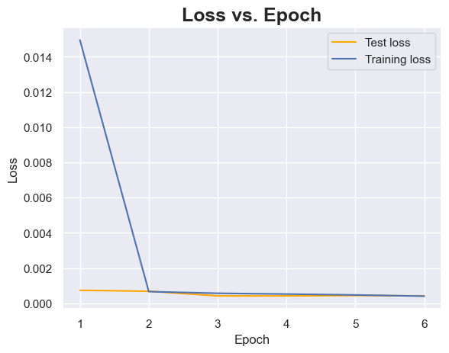
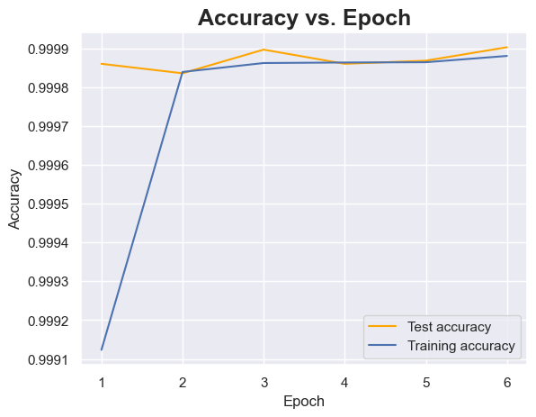
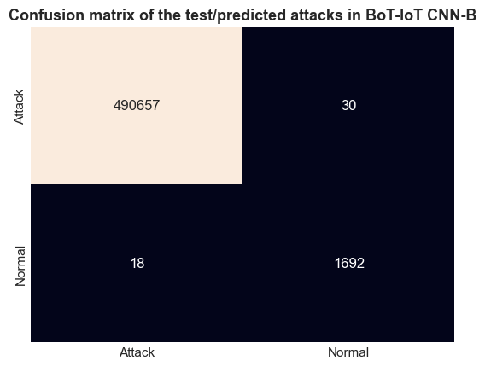
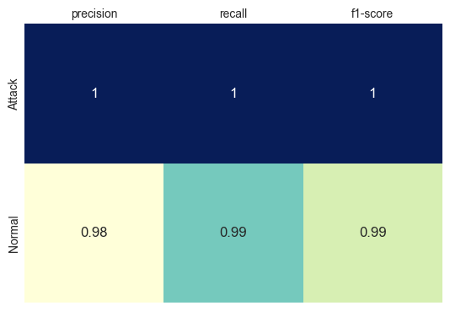

Creating three UNSW-NB15 subsets
Why do we want to create three new subsets?

So the researchers split the attacks into groups:

Known attacks (4 types):

Generic

Exploits

DoS

Reconnaissance

Unknown / zero-day attacks (5 types):

Fuzzers

Analysis

Backdoor

Shellcode

Worms

- UNSW-NB15-Basic (Train + Test)

Contains ONLY known attacks + normal traffic.

This is used for training the transfer learning model after freezing the convolutional base.

Why?
Because during training, the model should NOT see zero-day attacks.

- UNSW-NB15-Test+

Contains ONLY zero-day attacks + normal traffic.

This is used to evaluate whether the TL model can detect attacks it has NEVER seen before.

This is the “true” zero-day benchmark.

- UNSW-NB15-Test

Contains all 9 attacks + normal traffic.

This is used to evaluate overall performance:

How well does the model detect known attacks?

How well does it detect zero-day attacks when mixed together?

Maybe can create another subset?

- UNSW-NB15-Rare
contains the most rare attacks in iot

1. Define rare classes
rare_classes = ['Analysis', 'Backdoor', 'Shellcode', 'Worms']

backdoor 534
analysis 526
shellcode 223
worms 24

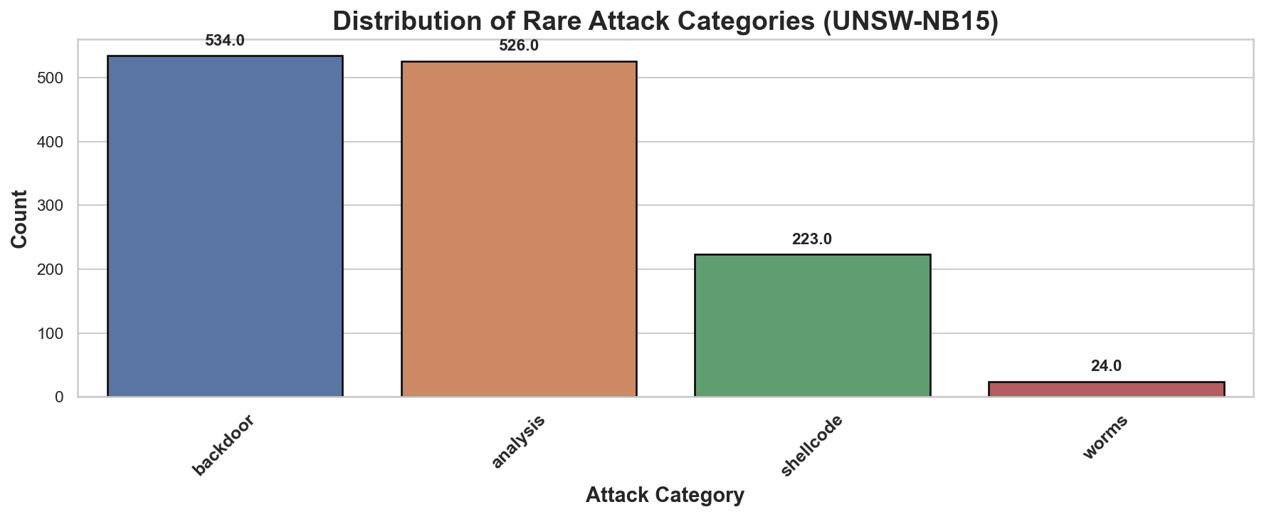

3. CNN-NONTL train

Hmm,,, okay ke ni

The model isnt detecting any attack samples as it might be too small
There are 99.24 % of NO detected and 0.76 % of detected samples (SIMILAR)

CORRECTION
Since were only using ¼ of the UNSW-NB15 dataset, we will do adjustments.
- Weight balancing
  - Didnt work as i thought it was, the result is worse
  - There are 99.24 % of NO detected and 0.76 % of detected samples
  - There are 100.00 % of NO detected and 0.00 % of detected samples

- SMOTE
- I decided to change the subsets size, using 2/4 of the unsw-nb15 datasets

